SPECIAL NOTE FOR PAVEMENT WEDGE AND SHOULDER
SEPARATE OPERATION

1.0 MATERIALS. Provide an Asphalt Mixture for Pavement Wedge conforming to Section 407 of the Standard Specifications or an Asphalt Surface Mixture conforming to Section 403 of the Standard Specifications, as applicable to the project, for the pavement wedge.

2.0 CONSTRUCTION. Place the Asphalt Mixture for Pavement Wedge or Asphalt Surface Mixture as a separate operation from the driving lane. Prime the existing shoulder with tack material as the Engineer directs before placing the wedge. Construct according to Sections 407.03 and 403.03 as applicable.

The wedge may vary in thickness at the edge of the driving lanes. Where existing site conditions permit, limit the outside edge thickness of the new paving limits to one inch above the existing shoulder wedge elevation.

The following sketch is primarily for the computation of quantities; however, the wedge will result in a similar cross-section where sufficient width exists. Do not construct a shoulder for placing the wedge unless specified elsewhere in the Contract.

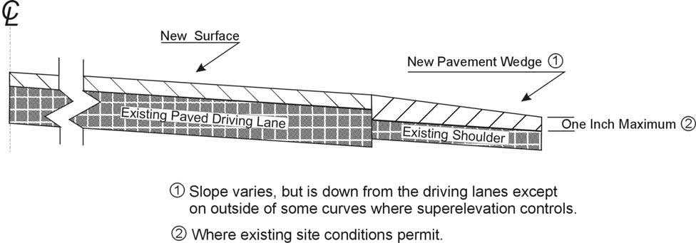

When the Engineer deems it appropriate to pave both the driving lane and the adjoining wedge monolithically, equip the paver with an approved Durable Pavement Edge shoe. See Section 403.02.07 and 403.03.14 for more information. Obtain the Engineer’s approval of the shoe to be used before placing the shoulder wedge monolithically with the driving lane.

3.0 MEASUREMENT. The Department will measure Asphalt Mixture for Pavement Wedge or Asphalt Surface Mixture placed as the pavement wedge according to Sections 403 and 407 as applicable.

4.0 PAYMENT. The Department will make payment for the completed and accepted quantities of Asphalt Surface Mixtures placed as pavement wedge according to Section 403. The Department will make payment for the completed and accepted quantities of Asphalt Mixture for Pavement Wedge according to Section 407.

1-3230 Pavement Wedge Separate Operation
01/18/2012

